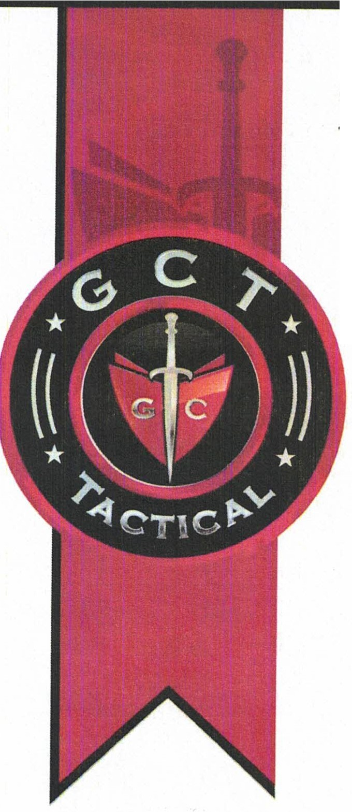
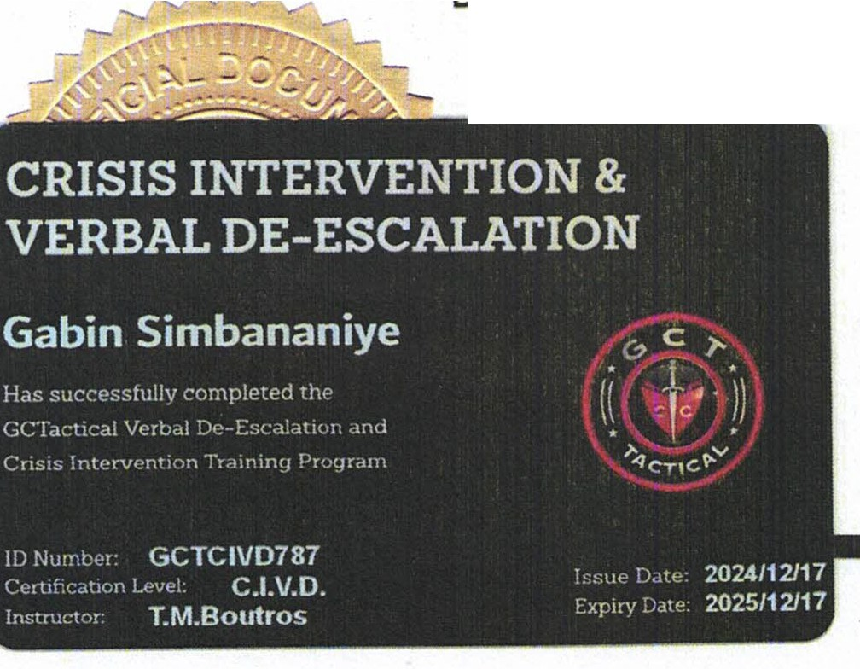
Certificate of Completion

GC Tactical
VERBAL DE-ESCALATION & CRIS!S INTERVENTION

gabin SimbananhJ£

This certificate is awarded in recognition of the knowledge and skills that have been demonstrated in the GCT Verbal De-Escalation & Crisis Intervention program sanctioned by GCTactical.

Level: Crisis Intervention & Verbal De-Escalation (CIVD)
Certificate Number: GCTCIVD787

2024/12/1712025/12/17
Date Issued / Expiry
S.l?fcKeff-
Sharon Trickett
President and CEO

CERTIFICATE VERIFICATION

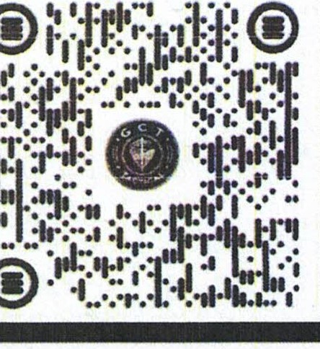


r-

OF COMPLETION
' '

IN RECOGNITION OF SUCCESSFUL COMPLETION IN:
CPR/ AED / First-Aid
(Adult/ Child / Infant/ Choking) AED / Injury & Universal Precautions

THIS CERTIFICATE IS PROUDLY PRESENTED TO:
SIMBANANIYE Gabin

The student has successfully met the requirements for certification by completing the cognitive training and skills evaluation in the specified course in terms of NCPRF® and in accordance with
the corresponding ILCOR, OSHA, and AHA®/ECC guidelines (2020).




Date: Oct 15, 2024 Renew:Oct15,2026 ID#: 42CA857
r-11 Course Provided By:

11:.1NationalCPRFoundation™
L
Instructor: Paul J. Scruton
Signature: Pl.LL_

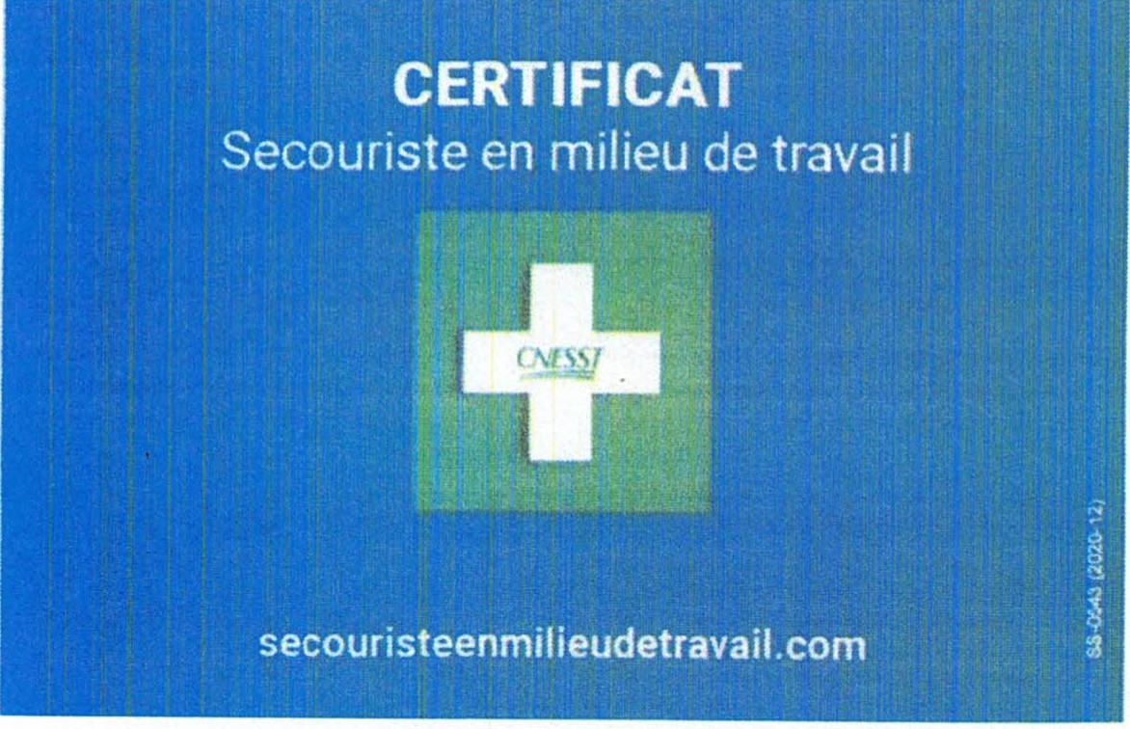
F30-519359

Gabin Simbananiye

a su1V1 avec succes ce cours
Secourisme en milieu de travail 16 h (A+)

17/04/2024 I 7/04/2027
 SOll'.S

CNESST

Prenom G: =a...,b"-'-inu. _
Attestation
Parti
F
n 6 la formation
R
g
Norn: Simbanaoiye
cipatio
lor,,
Date de naissance
1958-02-21

a compfete avec succes la formation SIMDUT 2015

En date du [ 2024-04-19
Oi
n
Toco

<9,._(9
,..-';,;·.
Fi
l/ I
'- .t-:" .⁷
0

Formation en entrt'pri-.e
Formation continue
R•connoi&sanced,socquls
fpoutaouais.com

