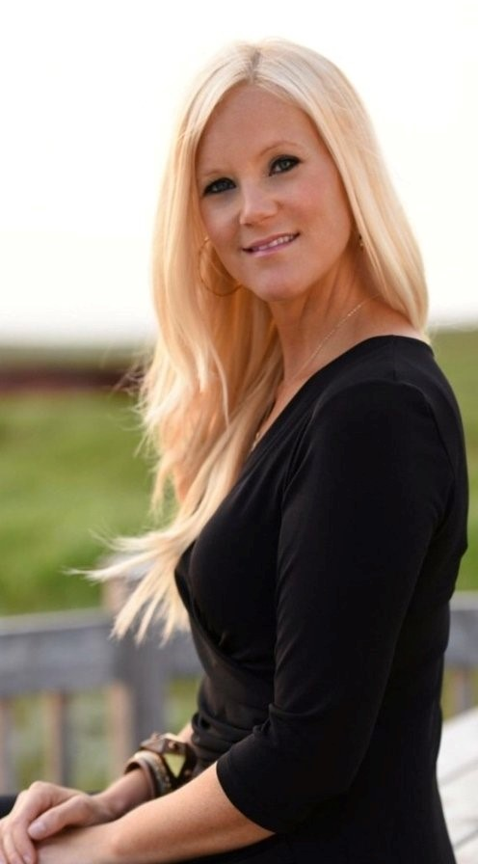 |  | Elyse Thorne
Experienced, result-driven Business and Marketing Professional successful background in the Automotive industry and proven expertise in maximizing productivity in sales and service. Responsible public relations and master trainer in promoting automobile sales consultants. Management of staff, organizing and supervising National and International Auto Shows and major Automobile events. Professional, hands-on training in all aspects of professional management of dealerships including Service, Sales, F&I and Accounting.  “Dedicated to the importance of professional integrity and exceeding personal and professional goals!”  561-725-2807  elysethorne8@yahoo.com  _____________________________________  Proficient with Microsoft office, Excel, PowerPoint. Detailed oriented, excellent organizational skills.  Strong verbal and written communication skills in both English and French with dual citizenships, United States of America, and Canada. |  | Northwood University  BBA - Magna cum laude Automotive Marketing and Management  Canadian Automotive Institute  BBA – with honors Automotive Marketing and Management  _____________________________________________________________________  Ford Lincoln Motor Company 2012 - Present  Master Trainer  Master training for all sales consultants on new and future Ford Lincoln vehicles in Canada. Public relations, managing and supervising National and International Auto Shows. Certified Ford, Lincoln, Ford Pro, Heavy duty trucks and Ford Fleet. First female trainer in Canada. Ranked top Master trainer in Canada for both Ford and Lincoln Motor Company. Represented the company for International and National Auto shows as well as ride and drive events.  Volkswagen of America 2002 - 2005  Client Account Manager/Auto Show Manager  Planning all aspect of Auto Show season. Interact with field staff regarding floorplans. Vehicle coordination and budget management. Public relations, managing all Volkswagen and Audi personnel for National and International Auto Shows in both USA and Canada. Researched and presented consumer trends in written reports to the company.  West Palm Hyundai 2002 - 2005  Service Manager Assistant/Service Advisor/Warranty Administrator  Performance-driven and knowledgeable Customer Service Advisor with comprehensive background in communicating with customers, resolving any problematics issues, handling customer complaints. Processed all warranty claims. Compiled technician time production and payroll.  Schumacher Volkswagen 2000-2002  Sales & Leasing Consultant  Consistently ranked top sale performer selling new Volkswagen and aftermarket accessories. Negotiated contracts and achieved timely settlements. Provided comprehensive customer service and follow-through.  _____________________________________________________________________

